Documentation – Prototype to demonstrate the use of BIRT Reporting Engine using XML as a data source

Prerequisites:
XML source file
BIRT Report Designer
BIRT 4.2.2 Report Engine runtime
Eclipse Juno with jdk 1.7

Approach:
There are two phases of developing this prototype. In Phase 1, use BIRT Report Designer to create a report with .rptdesign extension. In Phase 2, open the .rptdesign report in an eclipse project to view it. The following are the steps:

Phase 1 – Create Report
Open BIRT Report Designer Application. Click on File → New → New Report
Select a directory where you want to save the file and click Next.

Select “Blank Report” on the next screen and click on Finish.

In “Outline” pane at the bottom left, Right click on “Data Sources” and click on “New Data Source”. A dialog box shall open. Select the options as shown in the following diagram and name the data source.

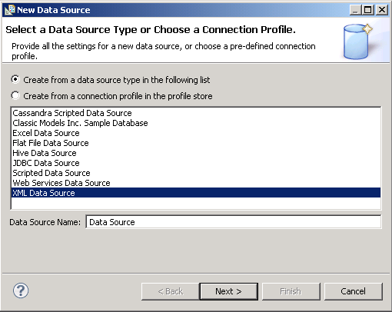
Figure1: Creating Data Source

Click Next. The following screen will open. Specify the path to your XML file by clicking on “Browse” button. A sample XML can be found in the Appendix A.
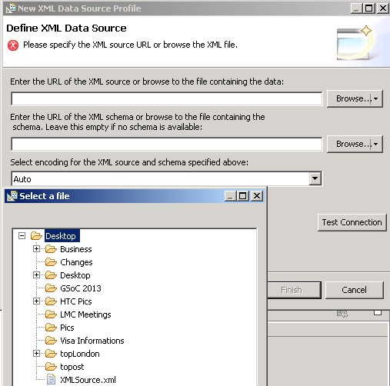
Figure 2: Specify XML file

After selecting the path, click on “Finish”. The data source is created.

The next step is to create a Data set. In the Outline pane, right click on “Data Sets” and select “New Data Set”. The following dialog box open. Select a Data Source and name the new data set and click Next.

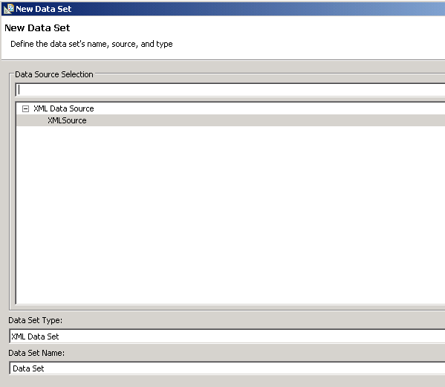
Figure 3: Creating a new Data Set

In the following screen, select the options as shown and click Next again.

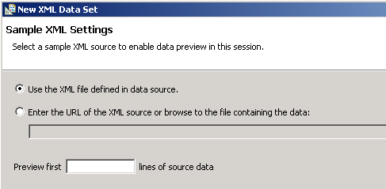
Figure 4: Sample XML settings

In the next two screens, define Row Mapping and Column Mapping respectively. These mappings will define how the XML structure will be mapped to a tabular structure for the report. After the mappings, the data set is created.

Now click on the “Palette” tab in the top left pane and drag a table in the “Layout” panel on the right side. Choose the number of columns and the data set you just created and click OK.

Then expand the “Data Sets” from the left and start dragging and dropping the columns into the table (Detail Row) in the “Layout” panel as shown in the following diagram.

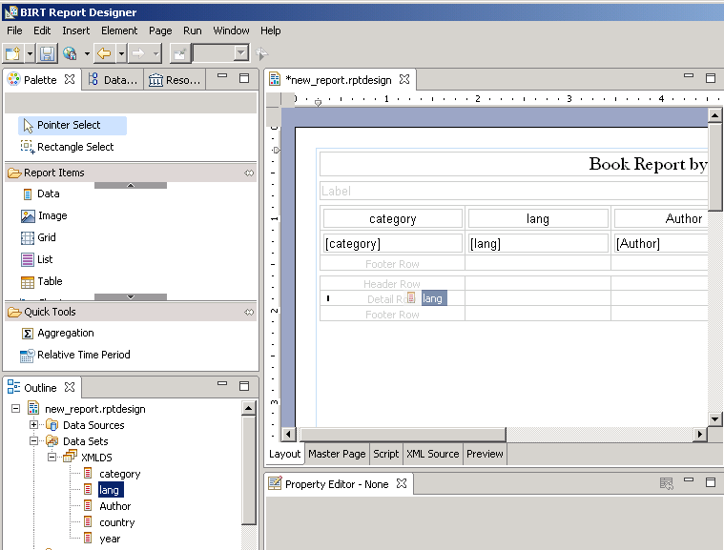
Figure 5: Filling in table columns with the data set.

The report is now ready. You can view it by clicking on the “Preview” tab.

Phase 2 – Java Project
The second phase is about creating an Eclipse project that will open up the report we created above, using the BIRT Report Engine API.

Create a new Project by selecting File → New → Project. In the wizard window, select “Java Project” and follow the steps of the wizard.

Create a new class file in the src folder. The file can be found in the Appendix B.

Download BIRT report engine 4.2.2. It comes as a zip file. Extract it to any location e.g., C:\<name of folder e.g., birt-runtime-4_2_2>

Add the path to the above folder in Java build path. Right click on the project name in the left hand pane and select “Properties”. A dialog box opens as follows:

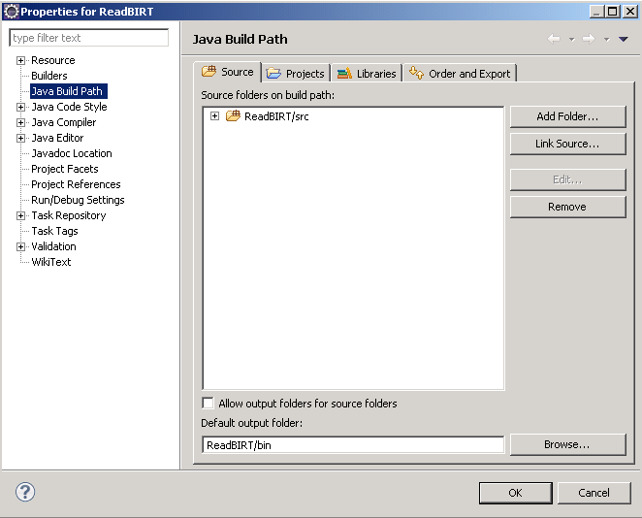
Figure 6: Java Build path

Go to tab “Libraries” and click on “Add External JARs”. Browse to the <birt-runtime-4_2_2\ReportEngine\lib> folder and select all the jar files in there. This will add BIRT report Engine APIs to the project.
To run the program, right click on the project and select Run As → Java Application as shown in the following figure:

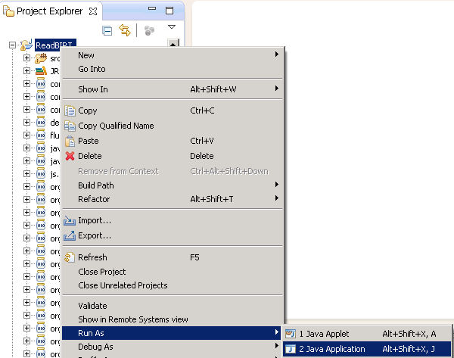
Figure 7: Build and Run Java application

Appendix A – XML Source

<?xml version="1.0"?>
<library>

<book category="COOKING">
<title lang="en">Everyday Italian</title>
<author name="Giada De Laurentiis" country="it"/>
<year>2005</year>
</book>

<book category="CHILDREN">
<title lang="en">Harry Potter</title>
<author name="J K. Rowling" country="uk" />
<year>2005</year>
</book>

<book category="WEB">
<title lang="en">XQuery Kick Start</title>
<author name="James McGovern" country="us" />
<author name="Per Bothner" country="us" />
</book>

<book category="WEB">
<title lang="en">Learning XML</title>
<author name="Erik T. Ray" country="us" />
<year>2003</year>
</book>

<audio format="CD" category="MUSIC">
<title lang="en">Feels Like Home</title>
<artist name="Norah Jones" country="us" />
<year>2005</year>
</audio>

<photo format="VCD" category="PICTURE">
<title lang="cn">Adventure to Tibet</title>
<photographer name="Zhang San" country="cn" />
<year>2002</year>
</photo>

</library>

Appendix B – Source code

import java.util.logging.Level;

import org.eclipse.birt.core.framework.Platform;
//import org.eclipse.birt.report.engine.api.EXCELRenderOption;
import org.eclipse.birt.report.engine.api.EngineConfig;
import org.eclipse.birt.report.engine.api.EngineConstants;
import org.eclipse.birt.report.engine.api.EngineException;
import org.eclipse.birt.report.engine.api.HTMLRenderOption;
import org.eclipse.birt.report.engine.api.IReportEngine;
import org.eclipse.birt.report.engine.api.IReportEngineFactory;
import org.eclipse.birt.report.engine.api.IReportRunnable;
import org.eclipse.birt.report.engine.api.IRunAndRenderTask;
import org.eclipse.birt.report.engine.api.IRunTask;
import org.eclipse.birt.report.engine.api.PDFRenderOption;

public class RunAndRenderTask {

public void runReport() throws EngineException
{

//IRunAndRenderTask task=null;
IReportEngine engine=null;
EngineConfig config = null;

try{
//System.setProperty("java.io.tmpdir", "c:/temp/test/testsampledb");
config = new EngineConfig( );
config.setLogConfig("c:/tmp/logs", Level.FINEST);
config.setBIRTHome("C:/birt-runtime-4_2_2/ReportEngine");
//config.setLogConfig(null, Level.FINEST);
Platform.startup( config );

IReportEngineFactory factory = (IReportEngineFactory) Platform
.createFactoryObject( IReportEngineFactory.EXTENSION_REPORT_ENGINE_FACTORY );
engine = factory.createReportEngine( config );
}catch( Exception ex){
ex.printStackTrace();
}

IReportRunnable design = null;
//Open the report design
//IReportRunnable design = null;
//Open the report design
design = engine.openReportDesign("reports/new_report.rptdesign");
IRunTask task = engine.createRunTask(design);

task.run("outputs/ps.rptdocument");

task.close();
engine.destroy();
Platform.shutdown();
System.out.println("Finished");
System.exit(0);

}

/**
* @param args
*/
public static void main(String[] args) {
// TODO Auto-generated method stub
try
{

RunAndRenderTask ex = new RunAndRenderTask();
ex.runReport();

}
catch ( Exception e )
{
e.printStackTrace();
}
}

}

